Idee

Decommissioning 🡪 IT Asset Management (it’s a Service Management Practice ITIL 4)

Struttura

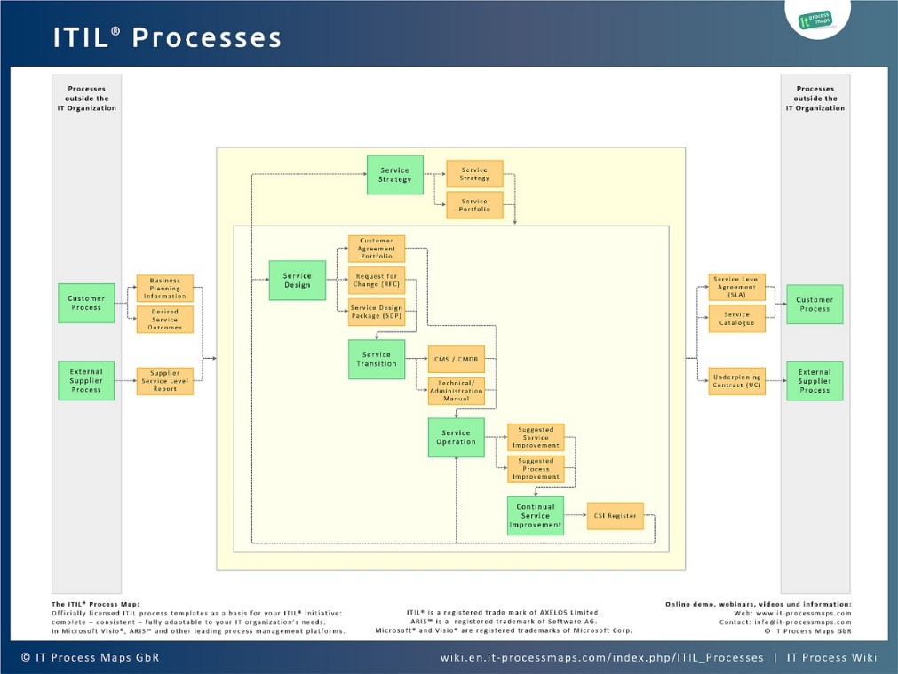Utilizzo dei processi di ITIL 3:

Adattarsi usando le 4 dimensioni:

Request:

Entry point: [How do you plan and execute IT asset disposal and decommissioning? (linkedin.com)](https://www.linkedin.com/advice/0/how-do-you-plan-execute-asset-disposal)

Structure:

* Introduction
  + Background and services
  + Context – structure/vision/strategy/challenges
  + IT structure/infrastructure/services
  + ITIL existing framework - governance
    - Service strategy
    - Service design
    - Service transition
    - Service operation
    - Continual service improvement
* Decommissioning plan
  + Risk analysis
  + Impact assessment
* CMS – Configuration Management System
  + Application of ITIL 4 practices when starting
* Guiding principles
* SVS/SVC
* 4 Dimensions
* Use of practices